MTN.*NIX.07 Lab - Access and Join Methods Part 1

Table access full scan

Step 3

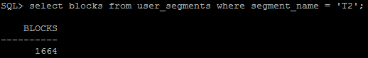

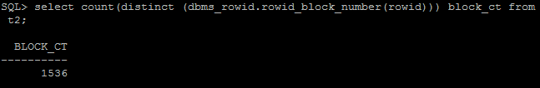

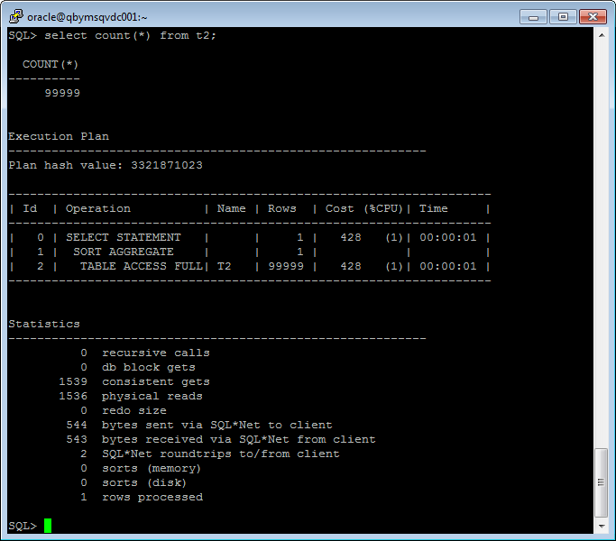

Step 5

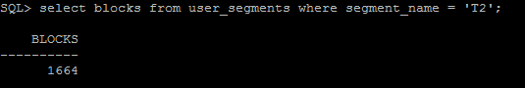

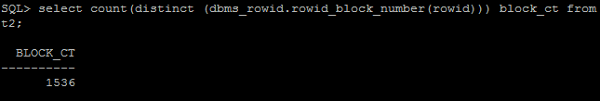

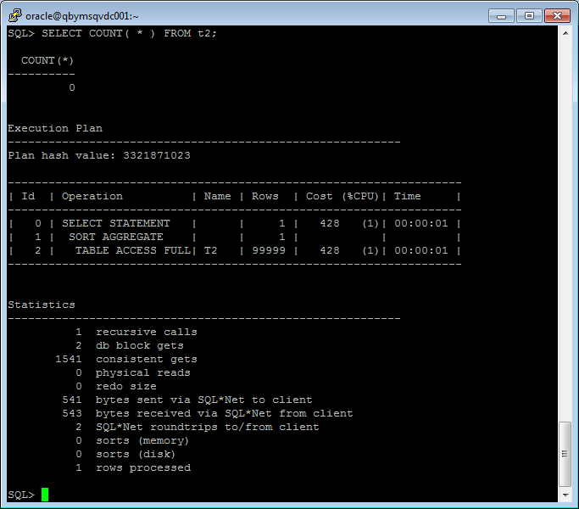

Step 7

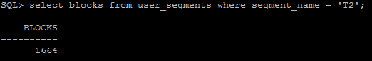

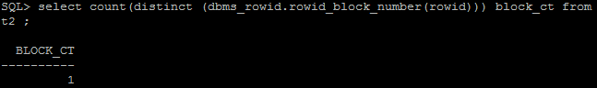

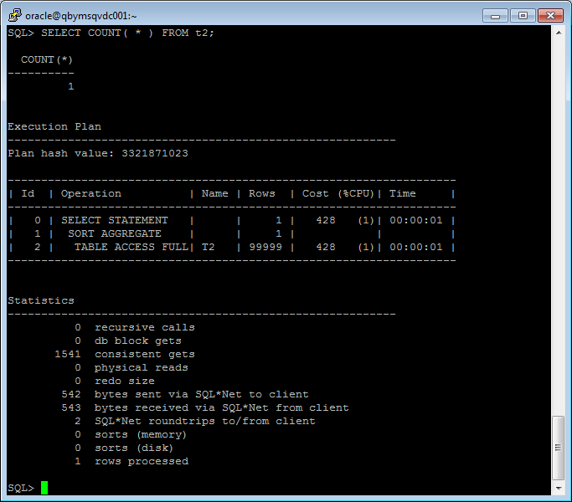

Step 9

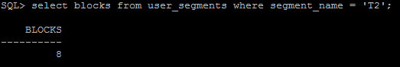

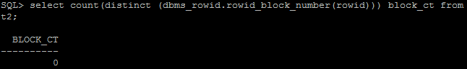

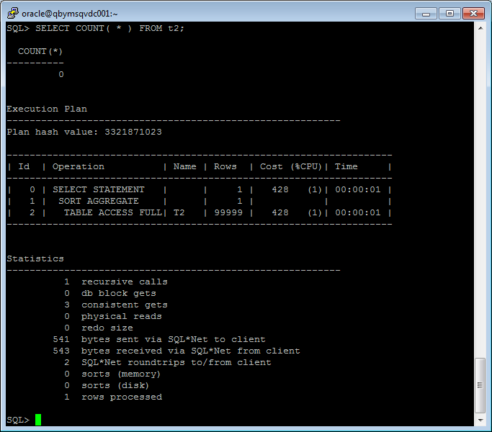

|  |  |  |  |  |  |
| --- | --- | --- | --- | --- | --- |
| № | Count of Blocks | Count of Used Blocks | Count of Rows | Consistent gets | Description |
| Step 3 | 1664 | 1536 | 99999 | 1539 | The consistent gets Oracle metric is the number of times a consistent read (a logical RAM buffer I/O) was requested to get data from a data block. When we insert 99999 rows, Oracle used 1536 blocks. Segment size increases discretely and it’s a main cause why Oracle reserved 1664 blocks. |
| Step 5 | 1664 | 0 | 0 | 1541 | High water mark is the maximum amount of database blocks used so far by a segment. This mark cannot be reset by delete operations. |
| Step 7 | 1664 | 1 | 1 | 1541 | Segment T2 consist of 1664 block and Oracle use 1541 Consistent gets for read blocks/ |
| Step 9 | 8 | 0 | 0 | 3 | TRUNCATE reset HWM |

Index Scan types

Index Clustering factor parameter



**CLUSTERING FACTOR** - столбец в представлениях dba_indexes, user_indexes.  
  
Показывает, насколько упорядочены строки в таблице по значениям индекса.  
  
**Если значение близко к общему количеству блоков, значит, таблица очень хорошо упорядочена.** В этом случае записи индекса в одном листовом блоке обычно указывают на строки, находящиеся в одних и тех же блоках данных.  
  
**Если значение близко к общему количеству строк, значит, таблица весьма неупорядочена.** В этом случае маловероятно, что записи индекса в одном листовом блоке указывают на те же блоки данных.

Index Unique Scan

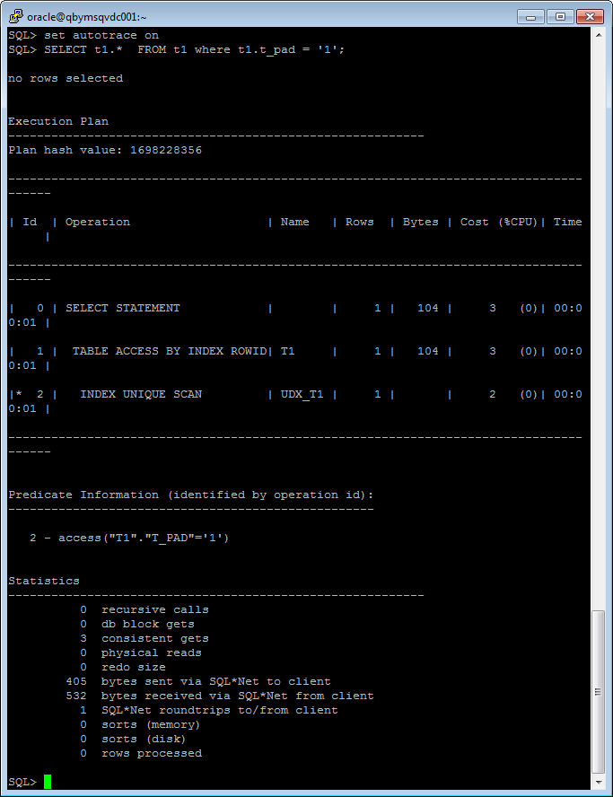

In contrast to an index range scan, an index unique scan must have either 0 or 1 rowid associated with an index key. The database performs a unique scan when a predicate references all of the columns in a UNIQUE index key using an equality operator. An index unique scan stops processing as soon as it finds the first record because no second record is possible.

Index Range Scan

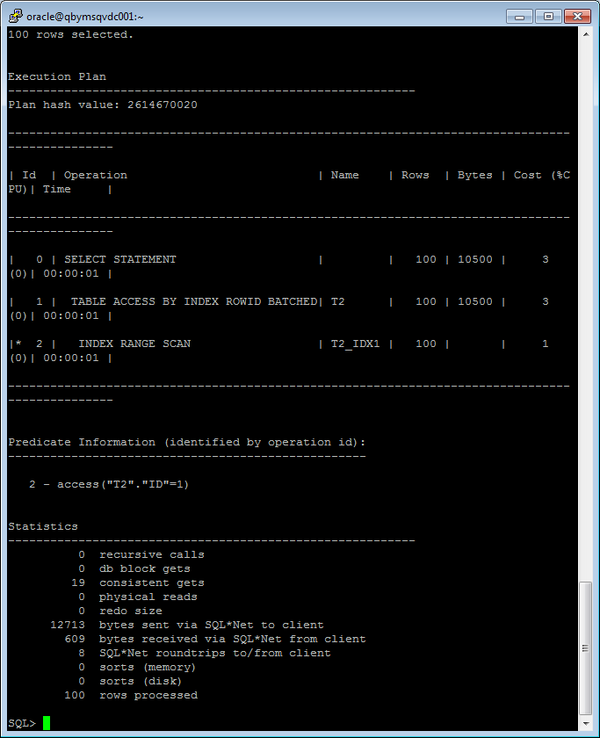

A range scan is one in which the index is scanned for a range of values and the easiest way to force this behavior is with constructs such as BETWEEN and BOOLEAN operators such as < and >.

Index Skip Scan

SELECT /*+INDEX_SS(emp idx_emp01)*/ emp.* FROM employees emp where ename = 'SCOTT';

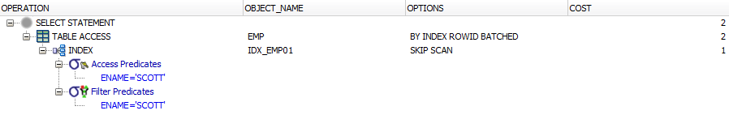

SELECT /*+FULL*/ emp.* FROM employees emp WHERE ename = 'SCOTT';

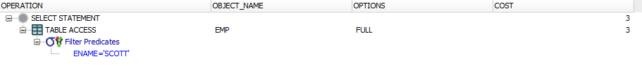

An index skip scan uses logical subindexes of a composite index. The database "skips" through a single index as if it were searching separate indexes. Skip scanning is beneficial if there are few distinct values in the leading column of a composite index and many distinct values in the nonleading key of the index.